Pippa’s Barbie adventures during lockdown 2020

Tuesday 14th April 2020
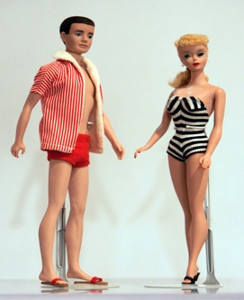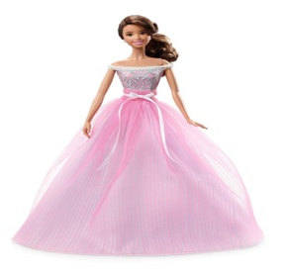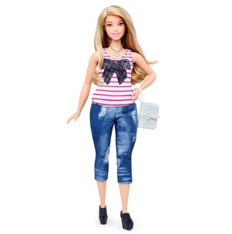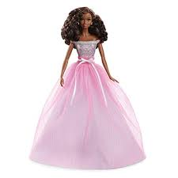
It was another sunny day in Fairlawns and Pippa decided it was time to have a fantasy day out, so she got 5 of her best Barbie dolls t make it happen. Pippa, Ruth and Becksy were trying really hard to keep safe and stay indoors during the dreaded “Lockdown” but sometimes it just got a bit hard as the house is small but their personalities are huge. Pippa sat on the sofa in the lounge and before she knew it, she had drifted off into a lovely dream.
Dan, Pippa, Ruth, Becksy and their lovely staff, Chinwe, all set off on their blue bus to drive to Littlehampton, their favourite seaside place. It took a very long time on their blue bus as it was quite old but they didn’t mind as they sang songs and listened to music on Pippa’s iPad.
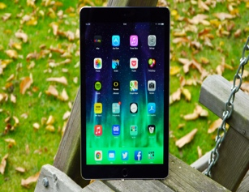
By the time they got there it was time for lunch, so they parked the bus in a safe carpark and went off to find their favourite fish and chip shop. They ordered their lunch and sat outside on the wall to eat it. Dan, Ruth and Becksy had fish and chips but Pippa and Chinwe had sausage in batter and chips with plenty of mayo – mmm said Pippa My Favourite!!
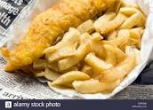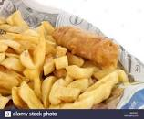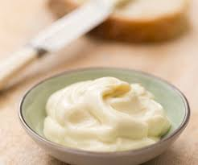
While they were eating their lunch the seagulls kept trotting up to them looking for scraps but Ruth was not planning on sharing her food, so she shooed them away. She got quite cross with them and ended up dropping some of her chips – she was not happy but the seagulls were delighted and thanked her for their food. Everyone laughed – such fun!!
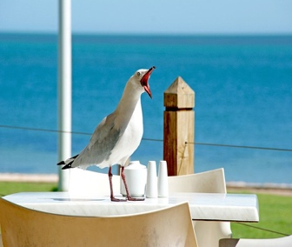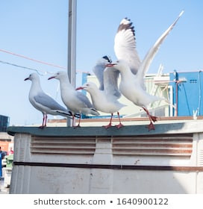
Once they had all finished eating it was time for some exercise, so they went for a walk along the promenade until they found the crazy golf – another favourite of theirs. They paid for the clubs and balls and went off to complete the course.
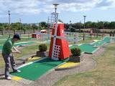
Some of the holes were quite difficult and when they got to one part there was a cave. “oooh” said Pippa ‘I’m not sure if I want to go in there, it looks a bit scary “. She decided on a cunning plan and persuaded Ruth to go first and just as Pippa thought there was a scary model of a monster hidden in the cave. It really made Ruth jump and she screamed out loud. The others all laughed and when she had calmed down Ruth agreed it was quite funny.
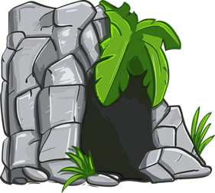
They all carried on playing until the end of the course and when they added up the scores Pippa was the winner with a really high score. They were all quite hot, so decided it was time for stroll along the promenade and an ice cream. Yum Yum!!

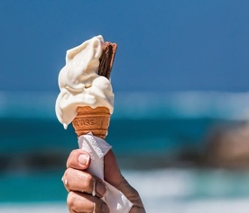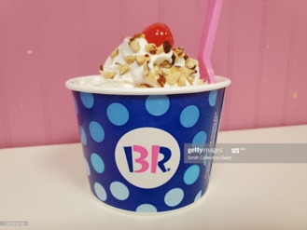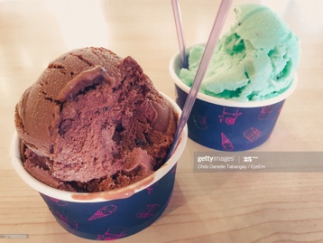
After they had finished their ice cream Chinwe managed to persuade Ruth, Pippa and Dan to go for a paddle in the sea but Becksy decided she was going to sit on the sand and read her magazine instead. They all ran down the beach and were laughing so much Pippa wet her knickers. Ha ha how very funny. She ran back up the sand and went to the toilets before she got too wet.
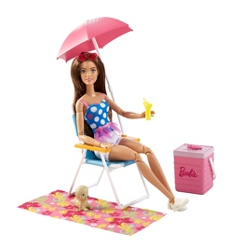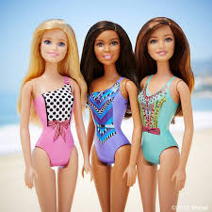
After all that excitement they all got back into their blue bus and drove home again to Fairlawns.
When they got home they all did their cleaning chores (I told you it was a fantasy!!) and then Pippa woke up and she was back on the sofa. To make up for being in lockdown they ordered a take away Pizza for dinner.

Then Pippa had her pepsi and chocolate and went to her room to watch her soaps.

